How to install and use Visual Studio Code and Xampp

Table of contents

1. Introduction

*1.1* Manual purpose

*1.2* Requirements

1. Visual Studio Code

*2.1* How to install

*2.2* Start and usage

1. Xampp

*3.1* Apache

*3.2* mySQL

**1. Introduction:**

1.1 Purpose of the document

This document is made to support you in the operation of the tools used for the game jam project.

It is going to help you with the installation and usage of multiple softwares, that are Visual Studio Code and Xampp.

1.2 Basic requirements

The following knowledge is required in order to fully understand the documentation:

* File installation, navigation and opening
* General settings manipulation
* Basic internet understanding
* Basic hardware understanding

**2. Visual Studio Code (VSCode)**

2.1 Installation guide

**Step 1 :** Type Visual Studio Code and click on Download under <https://code.visualstudio.com/>

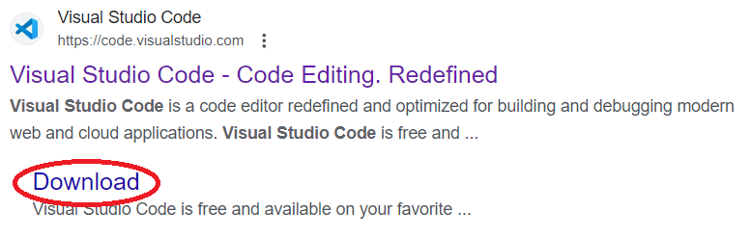

**Step 2 :** Select the correct version for your operating system :

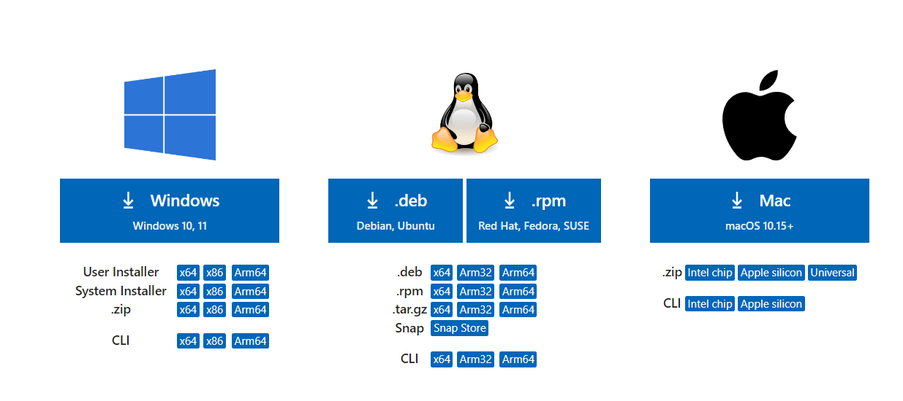

**Step 3 :** Start the .exe download and accept the conditions.

**Step 4 :** Choose the folder you want to install VSCode and press install. It should be installed and opened.

2.2 Starting and usage

**Step 1 :** Open VSCode.

**Step 2 :** Now go to “Extensions” on the left bar:

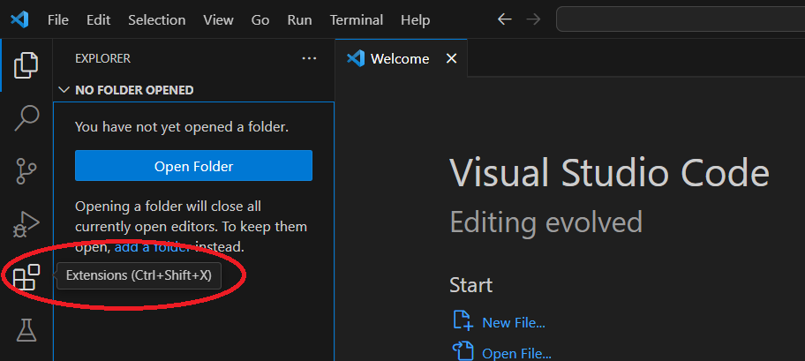

**Step 3 :** In the search bar, type “PHP” and install the following extension as it should be the first one to appear:

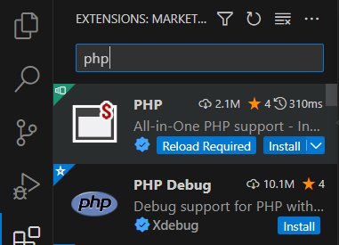

You can now create your .php files with Visual Studio Code.

If you have any questions / troubles while working with VSCode, feel free to take a look at their [frequently asked questions](https://code.visualstudio.com/docs/supporting/FAQ).

**3. Xampp**

3.1 Apache

How to install:

**Step 1 :** Go to the link <https://www.apachefriends.org/index.html> and choose the correct version based on your operating system.

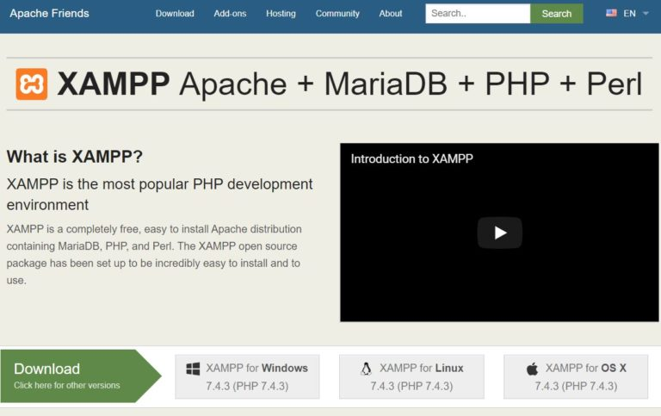

**Step 2 :** Find the installer in your files, run it as administrator, then click NEXT, NEXT,

FINISH and it should install itself.

**Step 3 :** Find the Xampp **Control Panel**, open it, then find the Apache module. On the Actions column, click start to enable Apache.

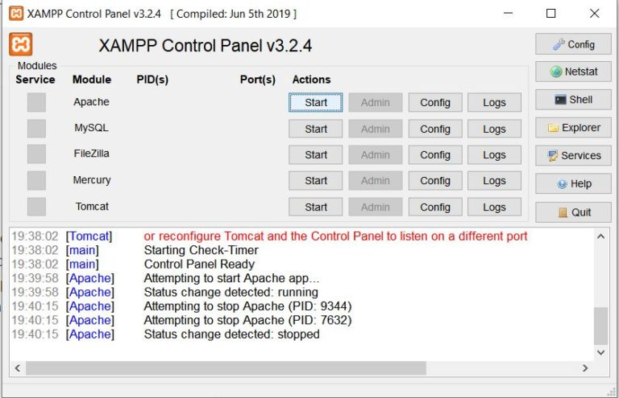

**Step 4 :** Open your web browser, then type in the following URL : <http://localhost>

If the default page for Xampp opens, then you have successfully installed your Xampp server.

3.2 mySQL / mariaDB

As you already have installed Xampp, you don’t need to download or install any more files.

Instead, you should go back to the Xampp control panel.

**Step 1 :** On the “Module” column, find mySQL, it should be the second one.

**Step 2 :** Click Start just as you did for Apache.

**Step 3 :** Click Admin. From now on, you will only have to import your sql database to your website.

To import the database, you will have to follow that go-through guide.

**Step 1 :** Download your database as a .sql file.

**Step 2 :** When you clicked Admin, an internet page opened : localhost:xxxx/phpmyadmin with x a number. On the left panel, you will find a “new database” (called “nouvelle base de données” on the screenshot). Click it.

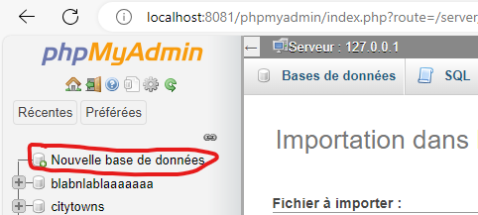

**Step 3 :** At the top menu, you will have to click on the “import” part



**Step 4 :** Drop the file on the page, and then click Execute.

You now have installed Xampp, started Apache as a web server, and uploaded your database. You can now work on it.

If needed, there is a [support forum](https://community.apachefriends.org/f/viewforum.php?f=34&sid=f407938f4dba75a52284ad3f416633f9) where you can look at the frequently asked questions and ask some yourself if you have trouble using Xampp.

You have successfully installed VSCode and Xampp, you can now use both on your computer.